Low Level Design (add COMPOSER module)

Project Code | Team6
Project Name | Media Composer and Artist Management System

Prepared/Modified by | Role | Date of Preparation
Raunak Agarwal | Senior Software Engineer | 13/11/2017
Reviewed by | Role | Date of Review
Vaishali Srivastava | Analyst | 14/11/2017
Approved by | Role | Date of Approval
Vishal Mali | Senior Analyst
Circulation List | raunak.agarwal@capgemini.com  shubham.ayush@capgemini.com  saptarshi.saha@capgemini.com  pratik.sahoo@capgemini.com  vaishali.srivastava@capgemini.com  vishal.mali@capgemini.com | Version Number of the template:1.0
Version Number | 1.3

Table of Contents

1. Description Of The Unit 3
2. References 4
3. Dependencies / Assumptions 5
4. Class Diagrams 6
5. Sequence Diagrams 7
6. Design Components 8
6.1 List Of UI Components 8
6.2 List Of Design Classes 8
7. Re-Usable Routines/Components 9
8. Messages 10
9. Configuration Files 11
10. Crud Matrix Table 12
11. Data Mapping Matrix 13
12. Action Flow Matrix 14
13. Stored Procedures 15
14. Program Specification / Pseudo Code 16
REVISION HISTORY OF THE WORK PRODUCT 17

Description Of The Unit

The add composer module allows the admin of the application to add new composers into the database. This module can be used only by the admin of the application.

On clicking on the insert button in the admin composer page, the admin is redirected to a add page. The admin enters all the details of the composer like composer name, composer born date, composer death date, composer caeipi number and composer music society id. If the entered composer details are invalid, appropriate error messages are displayed.

After entering all the composer details, the details are inserted into the database on clicking the insert button.

References

Reference | Description
Repository reference | https://github.com/pratik77/plp
Class Diagram | /Project Documents/Design Documents/HLD/Class Diagrams
URS | /Project Documents/Requirements/Media Presentation Document.doc
UTP | /Project Documents/Test Plan/UTP/Test Cases/AddComposer/UTP_AddComposerModule.xlsm
DB Design | /Project Documents/Design Documents/HLD/DB Design/ MediaComposerSystem_Group6_DBDESIGN.xls

Dependencies / Assumptions

Dependencies:
The admin should be logged in.

Assumptions:
The admin details are stored in the database.

Class Diagrams

Class Diagram

Sequence Diagrams

Sequence Diagram
NA

Design Components

List Of UI Components
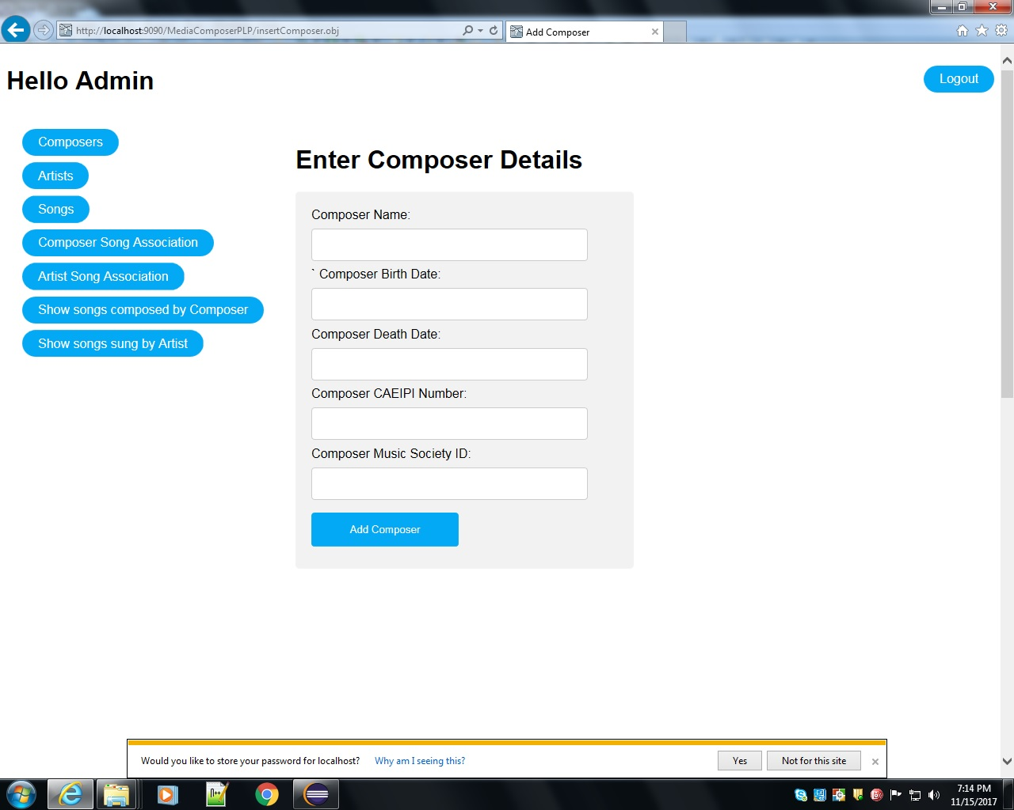

List Of Design Classes

Sr. No. | LLD Name | Class Name | Method Name | Method Description
1 | Add Composer Module | ComposerMasterDTO | Appropriate getters and setters methods | Getters retrieve the property values and setters set the property values
2 | Add Composer Module | MediaController | addComposer(Model model) : String  saveComposer(@ModelAttribute("composer") ComposerMasterDTO composer, Model model) : String | Sets the model attribute.  Calls insertComposer() of MediaServiceImpl class. If it returns object then it redirects to success page else it redirects to appropriate error message.
3 | Add Composer Module | MediaService | loadAllComposer():  List<ComposerMasterDTO >  insertComposer(): ComposerMasterDTO | Calls loadAllComposer() of MediaDAOImpl class and returns the result to controller.  Calls insertComposer() of MediaDAOImpl class and returns the result to controller.
4 | Add Composer Module | MediaDAOImpl | loadAllComposer():  List< ComposerMasterDTO >  insertComposer(): ComposerMasterDTO | Retrieves the list of subcategories from the database and stores in a list.  Inserts the composer details into the database and returns the result to MediaServiceImpl.

Re-Usable Routines/Components

Re-Usable Routines/Components

- CSS files
- Javascript files
- DataAccessException class
- Database properties files
- Logger properties files

Messages

#. | Type | Message Text
M1 | Error | Please fill out this field (if empty)
M2 | Error | Please fill out this field (if empty)
M3 | Error | Died date should be before Born Date
M4 | Error | CAEIPI Number should be 7 to 10 digits
M5 | Error | Music Society Id should be of 3 characters

Configuration Files

File Name | Path | Description
oracle.properties | /Development/Source | To configure database connection.
Web.xml | /Development/Source | To configure the bean properties.
Dispatcher-servlet.xml | /Development/Source | To configure the request mapping and view resolver.
logger.properties | /Development/Source | To configure the logger.
error.properties | /Development/Source | To configure error messages.
JPAContext.xml | /Development/Source | To configure the datasource, entity manager factory and transaction manager.

Crud Matrix Table

# | Table Name | Create | Update | Delete
1. | Composer_Master | Y | N | N

Data Mapping Matrix

Sr. No. | Screen Label | Field Source | Field Type | Data Type | Max Length | Data Flow | Mandatory
1 | Composer Name | NA | Label | NA | NA | UI | NA
2 | composerName | ComposerMasterDTO.  Composer_Name | TextBox | Varchar2 | 50 | UI→D | Yes
3 | Composer Born Date | NA | Label | NA | NA | UI | NA
4 | composerBornDate | ComposerMasterDTO. Composer_BornDate | Date | Date | NA | UI→D | Yes
5 | Composer Died Date | NA | Label | NA | NA | D→UI | NA
6 | composerDiedDate | ComposerMasterDTO. Composer_DiedDate | Date | Date | NA | UI→D | Yes
7 | Composer Caeipi Number | NA | Label | NA | NA | UI | NA
8 | composerCaeipiNumber | ComposerMasterDTO. CaeipiNumber | TextBox | Varchar2 | 10 | UI→D | Yes
9 | Composer Music Id | NA | Label | NA | NA | UI | NA
10 | composerMusicSocId | ComposerMasterDTO. MusicSocietyId | TextBox | Char | 3 | UI→D | Yes
11 | Add Composer | NA | Link | NA | NA | UI | NA

Legend
D → UI (Database to User Interface)
UI → D (User Interface to Database)
UI (User Interface Only)

Action Flow Matrix

Sr. No. | Action | Description | Process
1 | On click of Add new Composer Button in Admin insert Composer page | Redirected to the Add Composer page | The admin clicks on the add new composer button in the admin insert composer page and gets redirected to the add composer page.
2 | On click of Add Composer button in add page | The composer details are inserted into the database. | Data is entered in the fields by the admin which gets inserted into the database when add button is pressed.

Stored Procedures

# | Stored Procedure Name  (with Description) | Input/Out Parameters | Type | Size
1. | NA | NA | NA | NA

Program Specification / Pseudo Code

<ACTION :ADD_CLICK >

Pseudo Code:
- Client Side Scripting:
None

- Server Side Scripting:
BEGIN
Call addComposer(Model model) in Controller class
Navigate to AddComposer page
END

14. 2 <ACTION: ADDPRODUCT_CLICK>

Pseudo Code:

- Client Side Scripting:

IF ComposerName is Empty
Print Error Message M1
IF ComposerBornDate is Empty
Print Error Message M2
IF invalid ComposerBornDate
Print Error Message M3
IF invalid ComposerCAEIPINumber
Print Error Message M4
IF invalid ComposerMusicSocietyId
Print Error Message M5

- Server Side Scripting:
BEGIN
saveComposer(@ModelAttribute("composer") ComposerMasterDTO composer, Model model) in Controller class in Presentation Layer
BEGIN
Call insertComposer(ComposerMasterDTO composer) in MediaServiceImpl class in Service Layer
BEGIN
Call Call insertComposer(ComposerMasterDTO composer) in MediaDAOImpl class class in Data Access Layer
BEGIN
Create query for insert records into Composer_Master
Return composer.
END
Return composer to Service Layer
END
Return composer to Presentation Layer

END
IF successful navigate to success page
Else show error message.
END

REVISION HISTORY OF THE WORK PRODUCT

# | Date | Version # | Section Changed | Details of changes made | Approved By
1 | 13/11/2017 | 1.0 | LLD prepared | N/A | Vishal Mali
2 | 05/11/2017 | 1.1 | Reusable components,  Pseudo code | Reusable components added.  The pseudo code is modified as per the specified flow. | Vishal Mali
3 | 08/11/2017 | 1.2 | Reusable components,  References,  Data Mapping Matrix. | Reusable Components added.  File name with relative path is added in the references section.  The name of text boxes(screen label is changed). | Vishal Mali
4 | 09/11/2017 | 1.3 | Configuration files,UI Components | Paths of the configuration files is updated and UI components(Screen Shots) added. | Vishal Mali

